1. Create django project : amazon & open in VS code
2. Open VS code terminal and create Django app :product
3. Register application in settings.py
4. Create database “amazon” in workbench
5. Add database details in settings.py

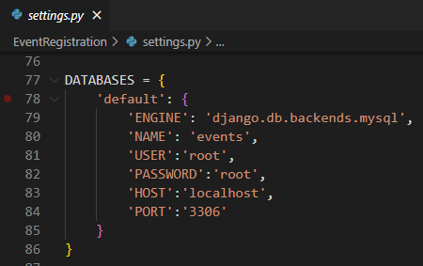

1. Start server
2. Check for database connection(open shell and do it)

>python manage.py shell

>>>from django.db import connection

>>>c = connection.cursor()

IF NO ERROR THEN GOOD TO GO

1. In product application, create model class : Pruduct (in model.py) with following fields : name, price

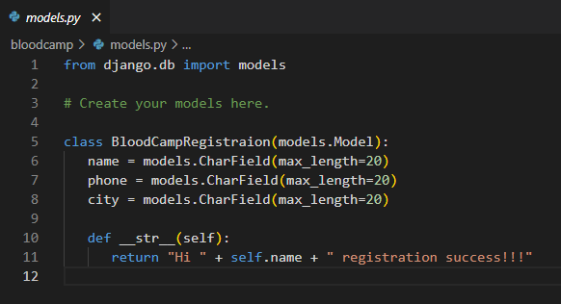

1. Register model class in admin.py

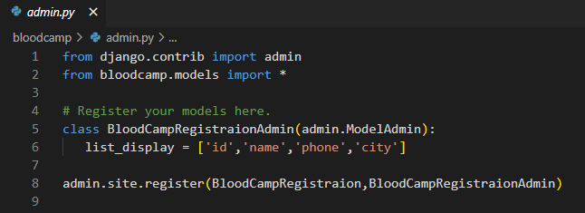

1. Makemigrations
2. Migrate
3. Check for table in workbench

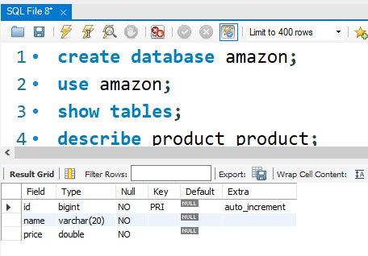

1. Create templates folder and register in settings.py
   1. Create product folder in templates folder
      1. Create add_product.html and view_product.html
      2. 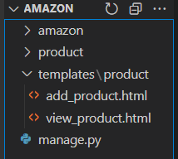
2. Create 2 views in product > views : view_product , add_product
   1. Initial code for views

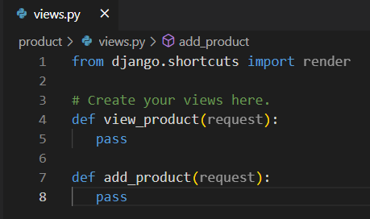

* 1. Create url pattern at application level for above view (create file bloodcamp_urls.py)

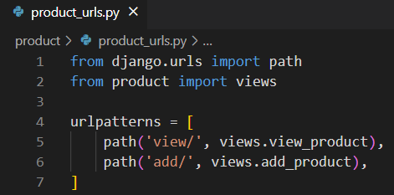

* 1. Include application level urls in project level urls.py

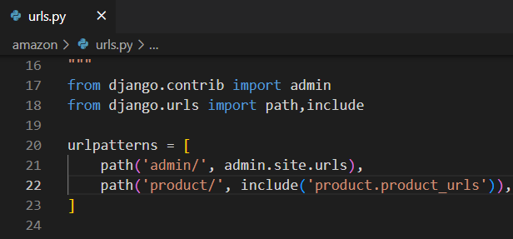

1. Create forms.py at application level (in bloodcamp folder) and add below code

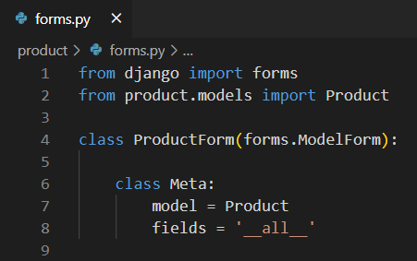

1. Code for above both views

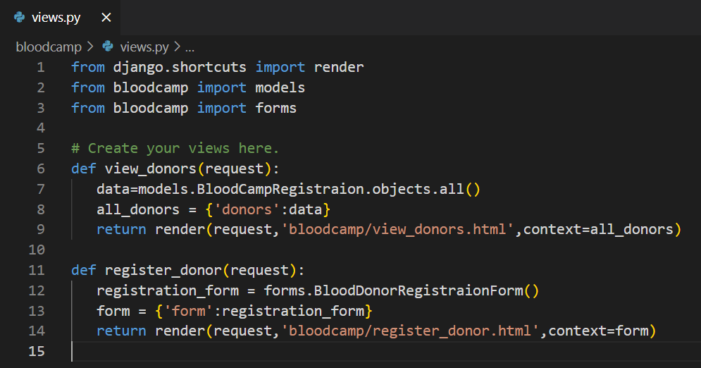

1. Code for above both html files

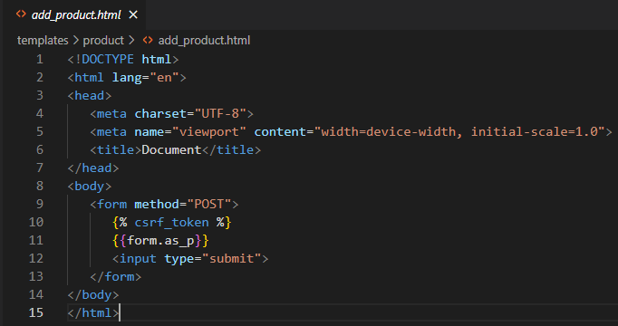

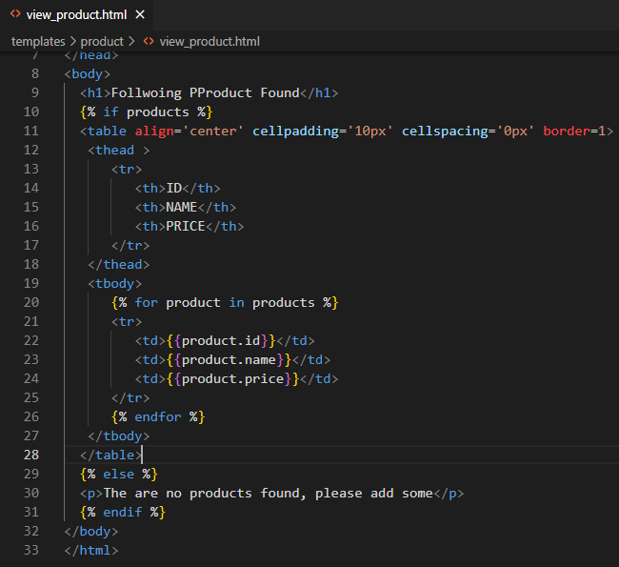

1. Restart sever
2. Write a code to collect data from form in add_product() view

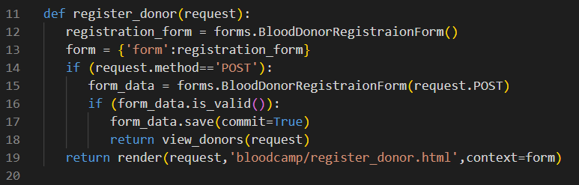

1. Final output

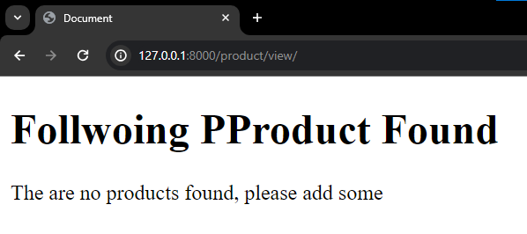

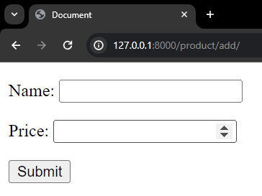

1. DONE
2. Lets add some products

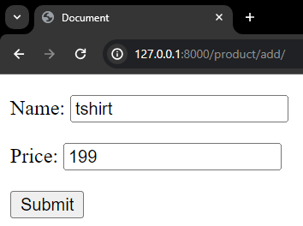 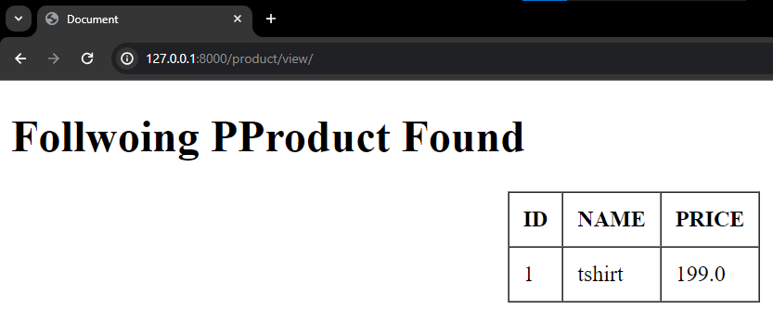

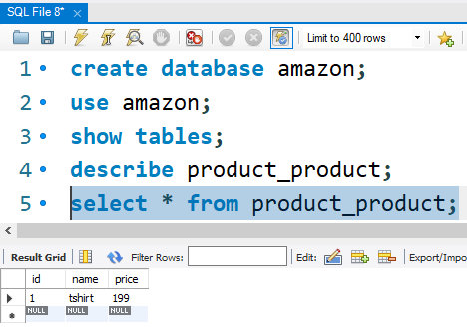

**Implementing CRUD**

1. Creating add product button in view_product.html